
Bachelor of Technology
Capstone Project

DEPARTMENT: ICT
PROGRAM: INFORMATION TECHNOLOGY
RQF LEVEL: 8

Project Topic:
AI-Based Poultry Disease Detection and Health Management System
A Case Study of Kinini Poultry Farm Cooperative

Submitted by:
ISHIMWE Didier
Reg No: 25RP18503

Supervisor:
Ms. Cecile MUSABYEMARIYA

May, 2026, Tumba

DECLARATION
I hereby declare that this project entitled "AI-Based Poultry Disease Detection and Health Management System" submitted in partial fulfillment of the requirements for the award of the Bachelor of Technology in Information Technology at Rwanda Polytechnic – Tumba College is my original work and has not previously been submitted for any degree or award at any other institution. I also declare that a complete list of references has been provided, indicating all sources of information quoted or cited in this work.
Done by: Signature
ISHIMWE Didier 25RP18503 ……………………………
Date: ……/……/2026

APPROVAL
This is to approve that the project work entitled "AI-Based Poultry Disease Detection and Health Management System" submitted by ISHIMWE Didier in partial fulfillment of the requirements for the award of the Bachelor of Technology in Information Technology at Rwanda Polytechnic – Tumba College is a record of work carried out by him under my guidance and supervision.

Supervisor:
Name: Ms. Cecile MUSABYEMARIYA
Signature: …………………………………………
Date: ……… / ……… / 2026

Head of Department of Information and Communication Technology:
Name:
Signature: …………………………………………
Date: ……… / ……… / 2026

DEDICATION
I dedicate this work to my beloved parents, brothers, and sisters, whose unwavering support, encouragement, and love have been my greatest source of strength throughout my academic journey. Their sacrifices and belief in me have made this achievement possible.
I also dedicate this work to my supervisors and lecturers at Rwanda Polytechnic – Tumba College, whose guidance and knowledge have shaped my understanding and skills in the field of Information Technology.
Finally, I dedicate this work to all smallholder poultry farmers in Rwanda, particularly those at Kinini Poultry Farm Cooperative, whose challenges and dedication to their work inspired this project. It is my sincere hope that this system will contribute in a meaningful way to improving their livelihoods and the health of their flocks.

ACKNOWLEDGEMENT
First and foremost, I would like to express my sincere gratitude to the Almighty God, whose grace and guidance have sustained me throughout this academic journey and made the completion of this project possible.
I would like to express my deepest appreciation to my supervisor, Ms. Cecile MUSABYEMARIYA, for her invaluable guidance, continuous support, constructive feedback, and encouragement throughout the development of this project. I also extend my sincere thanks to the lecturers and staff of the Department of Information and Communication Technology at Rwanda Polytechnic – Tumba College for the knowledge and skills they have provided throughout my studies.
My heartfelt gratitude goes to the management and farmers of Kinini Poultry Farm Cooperative for their cooperation and willingness to participate in this study, providing access to their farm and valuable data for the training of the AI model. I also wish to thank my classmates and friends for their companionship, encouragement, and moral support during the challenging moments of this academic journey.
Finally, I am deeply grateful to my family for their unconditional love, patience, and unwavering support throughout my studies. Their belief in me has been my greatest motivation, and this achievement belongs as much to them as it does to me.

ABSTRACT
Poultry farming is a vital source of food, income, and nutritional security for millions of smallholder households in Rwanda. However, poultry production is seriously threatened by infectious diseases such as Chronic Respiratory Disease (CRD) and Fowl Pox, which spread rapidly through flocks and cause significant economic losses if not detected and managed at an early stage. Most smallholder farmers rely on traditional observation methods to identify diseases, which are often inaccurate and result in delayed treatment. Access to qualified veterinary professionals is also limited in many rural areas, making timely diagnosis and intervention difficult.
This project presents the design and development of an AI-Based Poultry Disease Detection and Health Management System, with Kinini Poultry Farm Cooperative as the primary case study. The system uses Convolutional Neural Network (CNN) architecture to analyse uploaded images of chickens and classify them into three categories: Chronic Respiratory Disease (CRD), Fowl Pox, or Healthy. The trained model demonstrated strong and reliable classification performance across all three disease categories.
The system was developed using TensorFlow and Keras for the AI model, and includes a user-friendly web-based interface that allows farmers to upload chicken images and receive disease detection results together with practical health management guidance. The system was evaluated through AI model performance testing, functionality testing, usability testing with farmers at Kinini Poultry Farm Cooperative, and reliability testing, all of which confirmed that the system meets its intended functional and performance requirements.
The results of this project demonstrate that AI-based image classification can be effectively applied to support early poultry disease detection in resource-constrained smallholder farming environments. The system offers a scalable, accessible, and cost-effective solution that has the potential to reduce disease-related losses, improve flock productivity, and contribute to better livelihoods for rural poultry farming households in Rwanda.
Keywords: Artificial Intelligence, Poultry Disease Detection, Convolutional Neural Network, Image Classification, Health Management, Rwanda, Smallholder Farming
Contents
DECLARATION i
APPROVAL ii
DEDICATION iii
ACKNOWLEDGEMENT iv
ABSTRACT v
List of Figures ix
List of Tables x
CHAPTER ONE: INTRODUCTION 1
1.1 Background of the Study 1
1.2 Statement of the Problem 1
1.3 Research Objective 2
1.3.1 General Objective 2
1.3.2 Specific Objectives 2
1.4 Research Questions 2
1.5 Significance of the Study 3
1.6 Scope of the Study 3
1.7 Limitations 4
CHAPTER TWO: LITERATURE REVIEW 5
2.0 Introduction 5
2.1 Definition of Key Concepts 5
Artificial Intelligence (AI): 5
Machine Learning (ML): 5
Convolutional Neural Network (CNN): 5
Chronic Respiratory Disease (CRD): 5
Fowl Pox: 6
Image Classification: 6
Health Management Guidance: 6
2.2 Review of Related Literature 6
2.3 Empirical Review 7
2.4 Theoretical Review 8
2.5 Conceptual Framework 9
2.6 Identified Research Gaps 10
2.7 Conclusion 10
CHAPTER THREE: METHODOLOGY 12
3.0 Introduction 12
3.1 Research Design 12
3.2 Data Collection Methods 12
3.2.1 Image Dataset Collection 13
3.2.2 Observation 13
3.2.3 Interviews 13
3.3 System Analysis Methods 14
3.3.1 Functional Requirements 14
3.3.2 Non-Functional Requirements 15
3.4 System Design and Development Methods 16
3.4.1 Overview 16
3.4.2 Proposed Methodology Summary 16
3.4.3 AI Model and Techniques 17
3.5 Ethical Considerations 18
3.6 Conclusion 18
CHAPTER FOUR: SYSTEM ANALYSIS, DESIGN AND IMPLEMENTATION 20
4.0 Introduction 20
4.1 Software Development Model 20
4.2 Illustration of Existing System 21
4.2.1 Current System Workflow 21
4.2.2 Limitations of the Existing System 22
4.3 System Design of New System 22
4.3.1 System Architecture Design 22
4.3.2 System Block Diagram 23
4.4 System Diagrams 24
4.4.1 Data Flow Diagram (DFD) 24
4.4.2 Use Case Diagram 25
4.4.3 Entity Relationship Diagram (ERD) 26
4.5 System Implementation 27
4.5.1 AI Model Training and Performance 28
4.5.2 User Interface Implementation 29
4.5.3 Database Implementation 32
4.6 System Testing and Evaluation 32
4.6.1 AI Model Performance Evaluation 32
4.6.2 System Functionality Testing 33
4.6.3 Usability Testing 33
4.6.4 Reliability Testing 33
4.7 Summary 33
CHAPTER FIVE: CONCLUSIONS AND RECOMMENDATIONS 35
5.1 Main Contribution of the Project 35
5.2 Conclusions 35
5.3 Recommendations 36
5.3.1 Expand the Scope of Detectable Diseases 36
5.3.2 Develop an Offline-Capable Mobile Application 36

List of Figures
Figure 1:Iterative Development Model 29
Figure 2:System Architecture Design 32
Figure 3:System Block Diagram 33
Figure 4:DFD Level 0 (Context Diagram) 34
Figure 5:DFD Level 1 35
Figure 6:Use Case Diagram 36
Figure 7:Entity Relationship Diagram (ERD) 38
Figure 8:Confusion Matrix of AI Model Performance 39
Figure 9:System Login Page 40
Figure 10:System Dashboard Page 41
Figure 11: Image Upload and Disease Detection Page 41
Figure 12: Disease Detection Result and Health Management Guidance Page 42
Figure 13: Admin Dashboard and User Management Page 43

List of Tables
Table 1: Functional Requirements 23
Table 2: Non-Functional Requirements 24
Table 3: AI Model Performance Results 39

CHAPTER ONE: INTRODUCTION

1.1 Background of the Study
Poultry farming plays a vital role in providing food, income, and nutritional security for millions of households worldwide. In Rwanda, it serves as a key livelihood strategy for smallholder farmers, contributing to household food security and national economic development. Despite its importance, poultry farming in Rwanda faces serious challenges related to disease management, with diseases such as Chronic Respiratory Disease (CRD) and Fowl Pox spreading rapidly through flocks and causing high mortality and significant financial losses if not detected and treated early.
Most farmers rely on traditional observation methods to identify diseases, which are often inaccurate and lead to delayed diagnosis. Access to veterinary professionals is also limited in rural areas, making timely intervention difficult and leaving many disease outbreaks unmanaged until significant losses have already occurred.
Recent advances in Artificial Intelligence (AI), particularly Convolutional Neural Networks (CNNs), provide a powerful opportunity to address these challenges through automated image-based disease detection. It is within this context that this project proposes the development of an AI-Based Poultry Disease Detection and Health Management System, with Kinini Poultry Farm Cooperative as the case study, to help farmers detect diseases early and manage their flocks more effectively.

1.2 Statement of the Problem
Poultry farming is a critical source of income and nutrition for many rural households in Rwanda. However, the productivity of poultry enterprises is constantly threatened by infectious diseases that, if not identified and managed early, can cause devastating losses. At Kinini Poultry Farm Cooperative and similar smallholder farming operations across Rwanda, disease management remains largely manual and reactive rather than proactive.
Most smallholder farmers rely on subjective visual observation to identify disease conditions, which lacks the precision required for early-stage diagnosis and frequently leads to delayed treatment and preventable losses. Access to qualified veterinary professionals is severely restricted in many rural areas due to distance and cost, meaning that farmers cannot obtain timely diagnosis and guidance when outbreaks occur.
There is therefore a clear and pressing need for an AI-Based Poultry Disease Detection and Health Management System specifically designed for smallholder poultry farmers in Rwanda, capable of accurately identifying common diseases including CRD and Fowl Pox from uploaded chicken images and providing practical health management guidance to enable timely and appropriate intervention.

1.3 Research Objective

1.3.1 General Objective
The main objective of this project is to design and develop an AI-Based Poultry Disease Detection and Health Management System that uses image analysis and deep learning to help poultry farmers detect common diseases early and manage the health of their flocks effectively.

1.3.2 Specific Objectives
- To assess the existing poultry disease detection and management practices at Kinini Poultry Farm Cooperative in order to identify the limitations of current approaches.
- To design and develop an AI-based system using Convolutional Neural Networks (CNN) that can detect and classify poultry diseases including Chronic Respiratory Disease (CRD) and Fowl Pox from images of chickens.
- To train a machine learning model using collected and preprocessed poultry disease image datasets so that the model can accurately recognize common diseases affecting chickens.
- To implement a user-friendly web interface that allows farmers to upload chicken images and receive disease detection results and health management guidance.
- To provide health management guidance that can help farmers take appropriate action after disease detection.

1.4 Research Questions
- What are the current limitations of poultry disease detection and management practices at Kinini Poultry Farm Cooperative?
- How can Artificial Intelligence be used to detect poultry diseases such as CRD and Fowl Pox from images of chickens?
- How effective is a CNN-based AI system in accurately identifying and classifying common poultry diseases?
- How can an AI-based disease detection system support farmer in managing and improving the health of their chicken flocks?

1.5 Significance of the Study
This project is significant for several reasons. From a practical standpoint, the system provides smallholder poultry farmers with an accessible and affordable diagnostic tool that enables earlier detection of diseases, thereby reducing flock mortality, preventing disease spread, and improving farm productivity and household income. This is particularly important for farmers at Kinini Poultry Farm Cooperative and similar smallholder operations across Rwanda who currently lack access to reliable disease detection tools.
From an academic perspective, this research contributes to the growing body of knowledge on the application of AI in agricultural settings, and specifically addresses the under-researched area of AI-based poultry disease detection in sub-Saharan Africa. The study demonstrates how CNN-based deep learning can be effectively adapted to the constraints and realities of smallholder farming in a developing country context.
From a national development perspective, the project aligns with Rwanda's Vision 2050 and the Smart Rwanda Master Plan, both of which emphasis the importance of technology adoption and innovation-driven development in key economic sectors including agriculture. By demonstrating how AI can be applied to improve poultry health management, the project contributes to the broader national agenda of digital agricultural transformation.

1.6 Scope of the Study
This project focuses on the design, development, and evaluation of an AI-Based Poultry Disease Detection and Health Management System for smallholder poultry farmers. The system is scoped to detect two commonly reported poultry diseases in Rwanda: Chronic Respiratory Disease (CRD) and Fowl Pox. The primary case study site is Kinini Poultry Farm Cooperative, from which image data is collected with the informed consent of farmers and relevant stakeholders.
The research covers the full system development lifecycle including requirements analysis, data collection and preprocessing, AI model training and validation, system implementation, and evaluation. The evaluation phase includes AI model performance testing using standard metrics, system functionality testing, usability testing with potential end-users, and reliability testing across different image inputs.
The system is designed as a decision-support tool and does not replace professional veterinary diagnosis. Farmers are advised to seek veterinary consultation for definitive diagnosis and treatment, particularly for severe or ambiguous cases.

1.7 Limitations
Despite the potential contributions of this project, the study is subject to several limitations that should be acknowledged:
- Dataset Size and Diversity: The accuracy and generalization capacity of the AI model depends on the quality, size, and diversity of the training dataset. Limited or imbalanced datasets may affect the model's ability to correctly identify diseases across different chicken breeds, lighting conditions, and disease severities.
- Internet Connectivity: The web-based version of the system requires internet access, which may be unreliable in some rural areas of Rwanda. This could limit the system's accessibility for farmers in remote locations.
- Scope of Diseases: The system is limited to detecting CRD and Fowl Pox and does not cover the full range of diseases that may affect poultry in Rwanda. Future iterations of the system could expand the scope to include additional disease categories.
- Not a Replacement for Veterinary Services: The system is designed to assist farmers in making initial assessments and is not intended to replace the expertise and judgement of qualified veterinary professionals.

CHAPTER TWO: LITERATURE REVIEW

2.0 Introduction
This chapter reviews existing literature related to the AI-Based Poultry Disease Detection and Health Management System. It begins by defining key concepts used throughout the study, then examines the global and local context of poultry farming and disease management. The chapter explores how Artificial Intelligence and deep learning technologies, especially Convolutional Neural Networks (CNNs), have been applied to agricultural and livestock disease detection. It also reviews existing research on AI-based poultry disease detection systems, discusses technology adoption in smallholder farming contexts, and identifies gaps in existing research that this project seeks to address. The chapter concludes with a conceptual framework that underpins the proposed system.

2.1 Definition of Key Concepts

Artificial Intelligence (AI):
The simulation of human intelligence processes by computer systems, including learning from data, recognizing patterns, and making decisions with minimal human intervention. In this project, AI is used to automatically detect poultry diseases from uploaded images of chickens.

Machine Learning (ML):
A subset of AI in which algorithms are trained on data to identify patterns and make predictions without being explicitly programmed for each specific task. The disease detection model in this project is built using machine learning techniques.

Convolutional Neural Network (CNN):
A class of deep learning model specifically designed for processing image data. CNNs automatically detect spatial features such as edges, textures, and patterns relevant to classification tasks. This project uses CNN architecture to classify poultry disease images.

Chronic Respiratory Disease (CRD):
A contagious respiratory infection in poultry caused by Mycoplasma gallisepticum, characterised by nasal discharge, coughing, laboured breathing, and reduced productivity. CRD is one of the two target diseases in this project.

Fowl Pox:
A viral disease of poultry caused by Avipoxvirus, presenting in a cutaneous (dry) form with visible skin lesions or a diphtheritic (wet) form affecting the mucous membranes. Fowl Pox is the second target disease in this project.

Image Classification:
The process of assigning a category or label to an input image based on features learned from a training dataset. This is the core task performed by the AI model in the proposed system.

Health Management Guidance:
Practical recommendations provided to farmers following disease detection, including suggested preventive measures, basic treatment approaches, and advice on when to consult a veterinary professional.

2.2 Review of Related Literature
Recent advances in Artificial Intelligence, particularly in deep learning and computer vision, have generated considerable research interest in the application of AI to agricultural disease detection. Mohanty, Hughes, and Salathe (2016) demonstrated that a CNN trained on the PlantVillage dataset could identify 26 plant diseases across 14 crop species with an accuracy of approximately 99.35% under controlled conditions. While focused on plant diseases, this landmark study established the viability of deep learning for image-based agricultural disease classification and stimulated significant subsequent interest in applying similar methodologies to livestock and poultry health.
In the domain of poultry disease detection specifically, Theckedath and Sedamkar (2020) applied a CNN-based architecture to classify Newcastle Disease, Fowl Pox, and healthy chicken conditions from images, achieving classification accuracies above 90%. Their work highlighted the importance of data augmentation techniques including rotation, flipping, and brightness adjustment in improving model generalization when training datasets are limited. Akter et al. (2021) developed a deep learning model for poultry disease detection using transfer learning with the VGG16 architecture pre-trained on ImageNet, achieving an accuracy of approximately 94% in classifying multiple disease categories. Their findings demonstrated that transfer learning can significantly reduce data requirements when building high-performance disease detection models.
Neethirajan et al. (2021) conducted a broader review of AI applications in poultry farming, encompassing disease detection, behaviour monitoring, growth assessment, and environmental management. Their analysis concluded that deep learning-based systems offer significant advantages over rule-based and traditional machine learning approaches in terms of accuracy, scalability, and adaptability. They further emphasised the critical importance of developing AI systems that are deployable in low-resource environments, a challenge that this project directly addresses.
Regarding poultry disease management in developing countries, the Food and Agriculture Organization (FAO, 2020) notes that smallholder farmers in sub-Saharan Africa typically depend on manual observation and personal experience to identify disease conditions, leading to frequent misdiagnosis and delayed treatment. The World Organisation for Animal Health (WOAH, 2021) highlights that limited access to veterinary services in rural areas exacerbates the impact of common diseases including CRD and Fowl Pox, making early, community-level detection tools especially valuable.
Machuve et al. (2022) developed a deep learning system that detects poultry diseases by analysing images of chicken droppings rather than the chicken body itself. The system used CNN architecture to classify fecal images and successfully identified diseases such as Coccidiosis, Newcastle Disease, and Salmonella based on the colour, texture, and consistency of the droppings. This approach demonstrated that visible symptoms beyond the chicken's physical appearance can serve as reliable indicators for AI-based disease classification. Unlike that system, the proposed project in this study focuses on detecting diseases directly from images of the chicken's body, specifically targeting CRD and Fowl Pox at Kinini Poultry Farm Cooperative, offering a more direct and accessible approach for smallholder farmers in Rwanda.

2.3 Empirical Review
Empirical studies from various developing country contexts provide evidence for the effectiveness of AI-based and digital health tools in managing animal diseases and supporting smallholder farmers. A study conducted in rural Kenya investigated the use of mobile health technologies for remote monitoring of livestock diseases and found a 25% increase in farmer follow-up adherence when real-time health data tracking and automated reminders were provided to farmers (Geere et al., 2018). These findings suggest that digital tools can meaningfully improve the responsiveness of farmers and healthcare providers to emerging health conditions.
A study examining wearable and image-based diagnostic tools in agricultural settings by Islam et al. (2022) found that devices employing advanced AI algorithms achieved diagnostic accuracy comparable to expert assessment in controlled conditions. These findings reinforce the potential of AI-based image classification tools to serve as reliable first-line diagnostic instruments in resource-constrained settings such as smallholder poultry farms in Rwanda.
These empirical findings collectively support the feasibility and anticipated impact of the proposed AI-Based Poultry Disease Detection and Health Management System. The evidence suggests that such systems can facilitate earlier disease identification, reduce economic losses from unmanaged outbreaks, and improve the overall health management capacity of smallholder farmers in low-resource contexts.

2.4 Theoretical Review
This project is grounded in two complementary theoretical frameworks that inform both the system design and the expected patterns of user adoption.
The first is Rogers' Diffusion of Innovations Theory (2003), which identifies five key characteristics that determine whether a new technology will be adopted by a target population: relative advantage (perceived benefit over existing practices), compatibility (alignment with existing values and practices), complexity (ease of use), trialability (ability to experiment before committing), and observability (visibility of results). Applied to this project, the AI-based disease detection system must demonstrate a clear advantage over manual observation methods, be compatible with farmers' existing mobile phone usage habits, remain simple to use without requiring technical training, allow farmers to trial the system with low risk, and produce observable results such as reduced flock mortality and improved treatment outcomes.
The second theoretical foundation is the Technology Acceptance Model (TAM) proposed by Davis (1989), which posits that the adoption of a technology is primarily determined by two factors: perceived usefulness (the degree to which a user believes the system will improve their performance) and perceived ease of use (the degree to which a user believes the system will require minimal effort). In the design of the proposed system, both of these dimensions are prioritised through the development of a user interface that is intuitive, accessible, and clearly communicates disease detection results and management recommendations in a format that is understandable to farmers with varying levels of digital literacy.

2.5 Conceptual Framework
The conceptual framework underpinning this study integrates three intersecting domains: agricultural science (specifically poultry health and disease management), information technology (specifically AI, deep learning, and software systems development), and rural development (specifically technology adoption by smallholder farmers in developing countries).
At the core of the framework is the proposition that CNN-based deep learning applied to poultry disease image classification can serve as a bridge between the technical capabilities of modern AI and the practical disease management needs of smallholder poultry farmers in Rwanda. The system operationalises this bridge through a processing pipeline that moves from image input through preprocessing, AI-based classification, and health management guidance, ultimately delivering actionable and practical information to the farmer through a user-friendly interface.

The framework is structured around four key components that interact to produce the system's intended outcomes:
- Input Component: Farmers upload images of chickens showing possible disease symptoms through the system's user interface.
- Processing Component: The uploaded images are preprocessed and analysed by the trained CNN model, which classifies the image into one of three categories: CRD, Fowl Pox, or Healthy.
- Output Component: The system presents the disease classification result together with targeted health management guidance appropriate to the detected condition.
- Feedback Component: Farmer usage patterns, model performance metrics, and usability feedback inform ongoing improvements to the system.
The framework further recognises that the system's real-world effectiveness depends not only on the technical performance of the AI model but also on user acceptance, interface accessibility, and the contextual relevance of the health management guidance provided. Evaluation of the system therefore encompasses both technical and user-centred dimensions.

2.6 Identified Research Gaps
The review of existing literature reveals several significant gaps that the proposed system is designed to address:
- Geographic and Contextual Specificity: The majority of AI-based poultry disease detection systems have been developed for large-scale commercial farming in Asia, North America, or Europe. Research specifically addressing the detection needs of smallholder farmers in sub-Saharan Africa, and Rwanda in particular, remains very limited.
- Integration of Detection and Health Management: While several studies have demonstrated the technical feasibility of AI-based disease classification, few have developed systems that integrate disease detection with structured, actionable health management guidance for farmers.
- Accessibility in Low-Resource Environments: Many existing AI-based systems require high-bandwidth internet connections or high-performance server infrastructure. There is a shortage of lightweight, accessible systems designed specifically for deployment in rural, low-connectivity farming environments.
- Input Method Limitation: Existing AI-based poultry disease detection systems such as Machuve et al. (2022) rely on images of chicken droppings to detect diseases, which may not always be practical or accessible for smallholder farmers. There is a lack of systems that detect diseases directly from images of the chicken's body, which represents a more straightforward and farmer-friendly approach, particularly in rural farming environments like Kinini Poultry Farm Cooperative in Rwanda

2.7 Conclusion
The literature reviewed in this chapter demonstrates the significant and growing potential of AI-based image classification tools for poultry disease detection. Existing studies confirm that CNN-based deep learning models can achieve high accuracy in classifying disease conditions from images, and that digital health tools can meaningfully improve disease management outcomes in resource-constrained settings.
However, the review also reveals important gaps in the existing literature, particularly with respect to the development of contextually appropriate tools for smallholder poultry farmers in Rwanda and the integration of disease detection with practical health management guidance. The proposed AI-Based Poultry Disease Detection and Health Management System is designed to address each of these gaps and to make a meaningful contribution to the application of AI in agricultural development in Rwanda.

CHAPTER THREE: METHODOLOGY

3.0 Introduction
This chapter outlines the research methodology adopted to design, develop, and evaluate the AI-Based Poultry Disease Detection and Health Management System. It describes the research design, data collection methods, system analysis methods, and system design and development approach. The chapter also presents the functional and non-functional requirements of the system and outlines the ethical considerations observed throughout the research process. The methodology was guided by the need to develop a system that is technically reliable, practically accessible, and contextually appropriate for smallholder poultry farmers at Kinini Poultry Farm Cooperative in Rwanda.

3.1 Research Design
This study adopts a descriptive and experimental research design to guide the development and evaluation of the proposed system.
The descriptive component involves understanding the current challenges faced by poultry farmers at Kinini Poultry Farm Cooperative in detecting and managing common diseases such as Chronic Respiratory Disease (CRD) and Fowl Pox. This is achieved through observation of existing farming practices, consultation with farmers and veterinary personnel, and review of relevant literature on poultry disease management in Rwanda and similar developing country contexts.
The experimental component involves the development, training, and testing of an AI model using labelled poultry disease image datasets. The model is built using Convolutional Neural Network (CNN) architecture and evaluated through a series of performance tests to determine its accuracy, precision, recall, and F1-score. The experimental approach allows the study to systematically measure the effectiveness of the proposed system under controlled conditions and assess its readiness for real-world deployment.
Together, these two components provide a comprehensive methodological foundation that addresses both the contextual understanding of the problem and the technical development of the solution.

3.2 Data Collection Methods
Data collection for this project involved gathering both image data for training the AI model and contextual information about the current poultry disease management practices at Kinini Poultry Farm Cooperative. The following data collection methods were employed:

3.2.1 Image Dataset Collection
The primary data required for this project consists of labelled images of chickens affected by CRD and Fowl Pox, as well as images of healthy chickens. Images were collected from two main sources:
- Local Farm Images: Photographs of chickens at Kinini Poultry Farm Cooperative were taken with the informed consent of the farm management and farmers. Images were captured showing chickens with visible symptoms of CRD and Fowl Pox, as well as healthy chickens for comparison. A veterinary professional assisted in the identification and labelling of disease conditions in the collected images.
- Publicly Available Datasets: Publicly available poultry disease image datasets from online research repositories and veterinary databases were accessed to supplement the locally collected images. These datasets provided additional labelled examples of CRD and Fowl Pox to increase the size and diversity of the training dataset.

3.2.2 Observation
Direct observation was conducted at Kinini Poultry Farm Cooperative to understand the current disease detection and management practices used by farmers. The observation focused on how farmers identify disease symptoms, how they respond to disease outbreaks, and what tools or resources they currently use to manage poultry health. The findings from this observation informed the system requirements and guided the design of the health management guidance module.

3.2.3 Interviews
Semi-structured interviews were conducted with selected poultry farmers and veterinary personnel at Kinini Poultry Farm Cooperative. The interviews were designed to gather qualitative information about the challenges farmers face in disease detection, their expectations from a technology-based solution, and their level of familiarity with digital tools. The insights obtained from these interviews were used to inform the user interface design and ensure that the system meets the practical needs of its intended users.

3.3 System Analysis Methods
System analysis was conducted to identify the functional and non-functional requirements of the proposed AI-Based Poultry Disease Detection and Health Management System. The analysis was based on findings from the data collection phase, including observations at Kinini Poultry Farm Cooperative and interviews with farmers and veterinary personnel.

3.3.1 Functional Requirements
Functional requirements define the specific features and capabilities that the system must provide to meet the needs of its users. The following table presents the functional requirements identified for the proposed system:
Table 1: Functional Requirements
Functionality | Description
User Registration and Login | Allow farmers and administrators to securely register and log into the system using their credentials.
Image Upload Module | Allow users to upload images of chickens in JPG or PNG format for disease detection analysis.
Disease Detection and Classification | Automatically analyse uploaded chicken images using the trained CNN model and classify the detected condition as CRD, Fowl Pox, or Healthy.
Health Management Guidance | Provide farmers with practical recommendations and management guidance appropriate to the detected disease condition.
Detection Results Display | Present the disease detection result clearly to the user through the system interface, including the disease name and confidence level.
Database Storage | Store and manage image datasets, detection records, and system results in a secure database for future reference and model improvement.
Admin Dashboard | Allow administrators to monitor system usage, manage users, and review detection history and system performance.
Table 1: Functional Requirements

3.3.2 Non-Functional Requirements
Non-functional requirements define the quality attributes and performance standards that the system must meet. The following table presents the non-functional requirements of the proposed system:
Table 2: Non-Functional Requirements
Attribute | Description
Usability | The system interface must be simple, intuitive, and easy to navigate for users with varying levels of digital literacy, including smallholder farmers.
Accuracy | The AI model must achieve a minimum accuracy of 85% in detecting and classifying poultry diseases from uploaded chicken images.
Performance | The system must process uploaded images and return disease detection results within a reasonable time to ensure a responsive user experience.
Security | The system must ensure secure data transmission and storage through appropriate authentication and data protection measures.
Reliability | The system must provide consistent and stable detection results across different image inputs and operating conditions.
Scalability | The system must be capable of handling increased numbers of users and image uploads without significant degradation in performance.
Compatibility | The system must be accessible on commonly used devices including smartphones, tablets, and desktop computers through a web-based interface.
Table 2: Non-Functional Requirements

3.4 System Design and Development Methods

3.4.1 Overview
The AI-Based Poultry Disease Detection and Health Management System will be developed using a structured and iterative approach that combines software development and AI model development steps. The system is built using modern and widely adopted technologies that ensure reliability, scalability, and ease of use. The frontend user interface is developed using a web-based framework to ensure accessibility across different devices. The backend is developed using a server-side framework that handles API requests, data processing, and integration with the trained AI model. The database stores image records, detection results, and user information securely.
The AI model is built using Python with the TensorFlow and Keras deep learning frameworks. The model uses Convolutional Neural Network (CNN) architecture and is trained on a labelled dataset of poultry disease images collected from Kinini Poultry Farm Cooperative and publicly available sources. The trained model is integrated into the backend of the system and is invoked when a user uploads a chicken image for disease detection.

3.4.2 Proposed Methodology Summary
The Iterative Development Model was selected for this project because it allows the system to be built in manageable stages, with each stage involving planning, design, implementation, and testing. Feedback gathered at the end of each iteration is used to refine and improve the system in the next stage. This approach is particularly appropriate for the AI-Based Poultry Disease Detection and Health Management System because it allows the AI model and the system interface to be progressively improved based on testing results and user feedback from farmers and veterinary personnel at Kinini Poultry Farm Cooperative.
The development process follows these key steps:
- Requirement Analysis: Identify the needs of poultry farmers and determine the diseases to detect based on findings from observation and interviews at Kinini Poultry Farm Cooperative.
- System Design: Design the architecture of the system including data flow, core modules, and user interface layout.
- Data Preparation: Collect, label, and preprocess poultry disease images to create the training dataset.
- Model Development: Build and train the CNN model using TensorFlow and Keras, applying techniques such as image augmentation, normalization, and transfer learning to improve model performance.
- System Implementation: Develop the user interface and backend, and integrate the trained AI model into the system for disease detection and health management guidance delivery.
- Testing and Validation: Evaluate the model and system performance using accuracy, precision, recall, F1-score, and confusion matrix metrics, and conduct usability testing with potential end-users.
- Deployment: Deploy the system for use by poultry farmers at Kinini Poultry Farm Cooperative.

3.4.3 AI Model and Techniques
The AI model used for disease detection in this system is based on Convolutional Neural Network (CNN) architecture, which is well-suited for image classification tasks. The following techniques are applied in the development and training of the model:
- Model Type: Convolutional Neural Network (CNN) with multiple convolutional, pooling, and fully connected layers.
- Framework: TensorFlow and Keras, which provide comprehensive tools for building, training, and evaluating deep learning models.
- Image Preprocessing: All input images are resized to a standard dimension, normalized to a pixel value range of 0 to 1, and augmented using techniques such as rotation, flipping, zooming, and brightness adjustment to increase dataset diversity and reduce overfitting.
- Transfer Learning: Pre-trained CNN architectures such as VGG16 or MobileNet, previously trained on large image datasets, are fine-tuned on the poultry disease image dataset to leverage existing feature representations and improve model accuracy with limited training data.
- Training Split: The dataset is divided into training (70%), validation (20%), and testing (10%) subsets to ensure rigorous model evaluation.
- Evaluation Metrics: The model is evaluated using accuracy, precision, recall, F1-score, and confusion matrix to comprehensively assess its classification performance.

3.5 Ethical Considerations
This study observes strict ethical guidelines to protect the rights and welfare of all participants and stakeholders involved in the research process.
- Data Privacy and Consent: All images and data collected from Kinini Poultry Farm Cooperative are gathered with the full informed consent of the farm management and farmers. Participants are clearly informed about the purpose of the research and how their data will be used. No personal or sensitive information is collected without explicit permission.
- Responsible Use of AI: The AI system is designed to assist farmers in detecting poultry diseases and improving health management. It is not intended to replace professional veterinary advice. Farmers are encouraged to consult veterinary experts for definitive diagnosis and treatment when necessary.
- Accuracy and Transparency: Efforts are made to ensure that the AI model is trained and tested using reliable and representative data. The system clearly presents detection results to users while acknowledging that predictions are based on trained models and may not always be perfectly accurate.
- Academic Integrity: All research materials, datasets, and references used in this project are properly acknowledged and cited in accordance with academic standards to maintain honesty and avoid plagiarism.
- Fair and Beneficial Use: The system is developed with the goal of benefiting smallholder poultry farmers without causing harm or discrimination. The technology is applied in a manner that promotes responsible farming practices and supports sustainable poultry management in rural communities.

3.6 Conclusion
This chapter has presented the research methodology adopted for the design, development, and evaluation of the AI-Based Poultry Disease Detection and Health Management System. A descriptive and experimental research design was selected to address both the contextual understanding of poultry disease management challenges at Kinini Poultry Farm Cooperative and the technical development of the AI-based solution. Data collection methods including image dataset collection, observation, and interviews were described, and the functional and non-functional requirements of the system were identified and presented.
The iterative development model was selected as the most appropriate approach for building the system, ensuring that the AI model and user interface are progressively refined based on testing and user feedback. The chapter also outlined the AI model architecture, training techniques, and evaluation metrics, and described the ethical considerations observed throughout the research process.

CHAPTER FOUR: SYSTEM ANALYSIS, DESIGN AND IMPLEMENTATION

4.0 Introduction
This chapter presents the comprehensive analysis, design, and implementation of the AI-Based Poultry Disease Detection and Health Management System developed for Kinini Poultry Farm Cooperative. The chapter begins with a review of the software development model employed, followed by an analysis of the existing system currently used at the farm, a description of the proposed new system, and a detailed presentation of the system design including architectural components, data flow diagrams, use case diagrams, and entity relationship diagrams. The implementation section demonstrates the actual development of the system, including the AI model training process, the user interface, and the integration of all system components. Throughout the chapter, diagrams and screenshots are provided to illustrate key aspects of the system design and implementation.

4.1 Software Development Model
The Iterative Development Model was adopted for this project because it allows the system to be built progressively in manageable stages or iterations. Each iteration includes the phases of planning, requirements gathering, design, implementation, testing, and evaluation. Feedback obtained at the end of each iteration is incorporated into the next stage, enabling continuous improvement of both the AI model and the system interface.
This model is particularly appropriate for the AI-Based Poultry Disease Detection and Health Management System for several reasons. First, the AI model requires iterative refinement as more training data is collected and model performance is evaluated. Second, the user interface benefits from repeated testing with farmers and veterinary personnel to ensure it meets practical usability requirements. Third, the iterative approach allows errors and weaknesses to be identified and corrected early in the development process, reducing the risk of major failures at the final deployment stage.
The figure below illustrates the iterative development model used in this project:

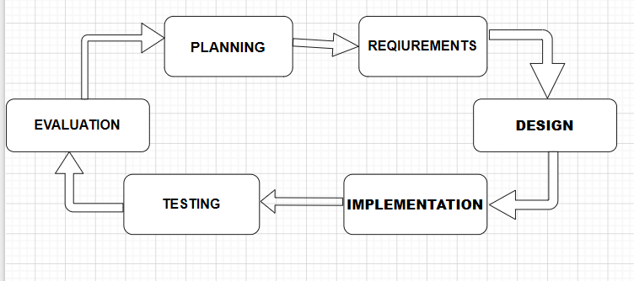
Figure 1:Iterative Development Model

4.2 Illustration of Existing System
The current poultry disease detection and management system at Kinini Poultry Farm Cooperative is entirely manual, relying on the personal observation and experience of farmers and occasional visits from veterinary personnel. This section describes the workflow of the existing system and identifies its key limitations.

4.2.1 Current System Workflow
The existing disease detection workflow at Kinini Poultry Farm Cooperative follows a manual process with no digital tools or automated support. Farmers observe their chickens visually on a daily basis and attempt to identify any signs of illness based on personal experience. When a farmer suspects that a chicken may be sick, the following steps typically occur:
- The farmer visually inspects the affected chickens, looking for visible symptoms such as swollen areas, skin lesions, nasal discharge, or abnormal behaviour.
- Based on personal experience or advice from fellow farmers, the farmer makes an informal assessment of the possible disease condition.
- If the condition appears serious, the farmer may attempt to contact a veterinary officer, which can take considerable time due to distance and limited availability of veterinary services in the area.
- In many cases, treatment is applied based on the farmer's own judgement or advice from other farmers, which may be inaccurate or delayed.
- Disease records are kept manually on paper if at all, with no systematic tracking of outbreak history, treatment outcomes, or flock health trends.

4.2.2 Limitations of the Existing System
The current manual system at Kinini Poultry Farm Cooperative has several significant limitations that negatively affect poultry health outcomes and farm productivity:
- Inaccurate Disease Identification: Farmers rely on subjective visual observation without any standardised diagnostic criteria, leading to frequent misidentification of diseases and inappropriate treatment.
- Delayed Diagnosis and Treatment: The absence of an automated detection tool means that diseases may spread significantly through the flock before any action is taken, resulting in higher mortality rates and greater economic losses.
- Limited Access to Veterinary Support: Qualified veterinary professionals are not readily available in the area around Kinini Poultry Farm Cooperative, making it difficult for farmers to obtain professional diagnosis and guidance when disease outbreaks occur.
- No Digital Record Keeping: Disease records are kept manually or not at all, making it impossible to track disease patterns, monitor treatment effectiveness, or make data-driven decisions about flock health management.
- No Health Management Guidance: Farmers receive no structured guidance on the appropriate management steps to take after identifying a possible disease condition, leaving them to rely on informal knowledge that may be inaccurate or outdated.

4.3 System Design of New System

4.3.1 System Architecture Design
The AI-Based Poultry Disease Detection and Health Management System is designed using a three-tier architecture consisting of the presentation layer, the business logic layer, and the data access layer. This architecture ensures a clear separation of concerns, making the system modular, scalable, and maintainable.
- Presentation Layer: The frontend user interface is built as a web-based application that allows farmers and administrators to upload chicken images, view disease detection results, and access health management guidance. The interface is designed to be simple and intuitive for users with limited digital literacy.
- Business Logic Layer: The backend server handles API requests from the frontend, coordinates image preprocessing, invokes the trained CNN model for disease classification, retrieves health management guidance from the database, and returns results to the user interface.
- Data Access Layer: The database stores user information, uploaded image records, disease detection results, and health management guidance content. It also stores the training datasets and model performance logs used during system development and evaluation.
The figure below illustrates the three-tier system architecture of the proposed system:
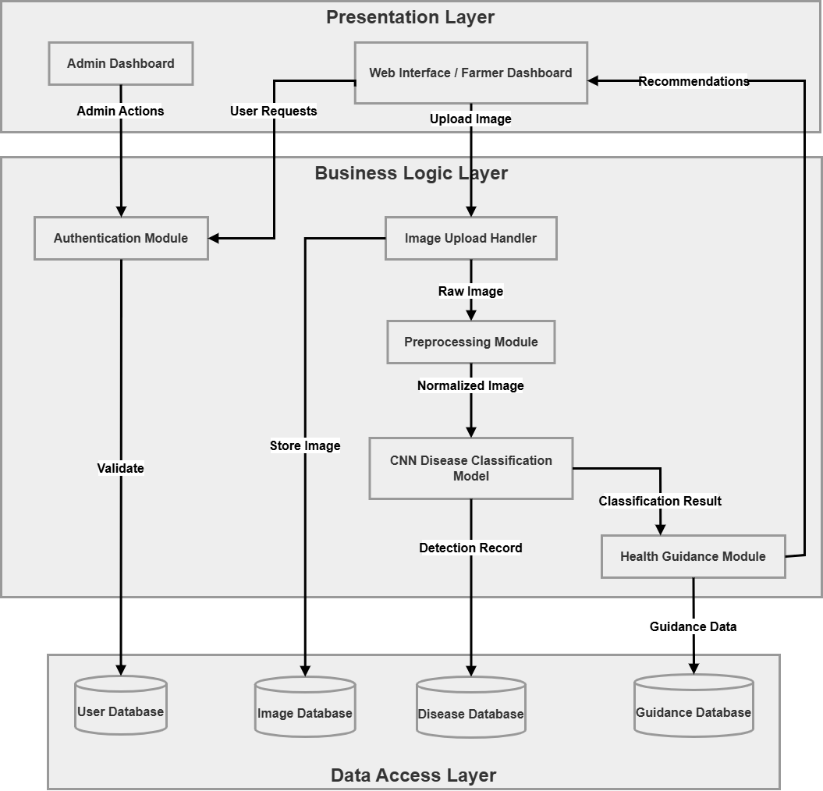
Figure 2:System Architecture Design

4.3.2 System Block Diagram
The system block diagram provides a high-level overview of the main components of the AI-Based Poultry Disease Detection and Health Management System and the interactions between them. The diagram shows how the user interface, image preprocessing module, CNN disease detection model, health management guidance module, and database interact to deliver disease detection results to the farmer.
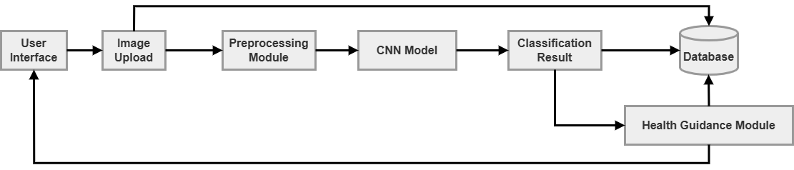
Figure 3:System Block Diagram

4.4 System Diagrams

4.4.1 Data Flow Diagram (DFD)
A Data Flow Diagram (DFD) is a visual representation that illustrates how data flows within a system. It shows the movement of data between external entities, processes, and data stores. DFDs help developers and stakeholders understand how the system operates, how inputs are transformed into outputs, and where data is stored or retrieved. Two levels of DFD are presented for the proposed system.
4.4.1.1 DFD Level 0 (Context Diagram)
The main external entities are the Farmer, who uploads chicken images and receives disease detection results and health management guidance; and the Administrator, who manages users and monitors system performance.
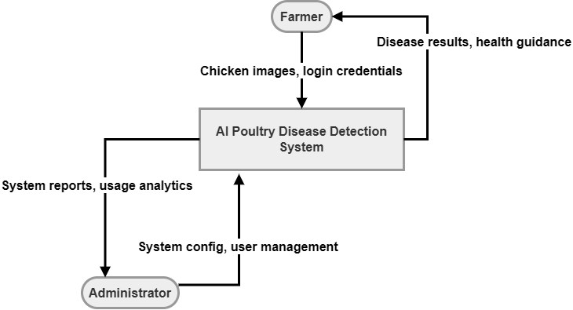
Figure 4:DFD Level 0 (Context Diagram)
4.4.1.2 DFD Level 1
The Level 1 DFD breaks down the AI-Based Poultry Disease Detection and Health Management System into its main internal processes. These processes include user registration and login, image upload and preprocessing, disease detection and classification, health management guidance delivery, and results storage and retrieval. Each process interacts with internal data stores and external entities based on the role of the user and the function being performed.
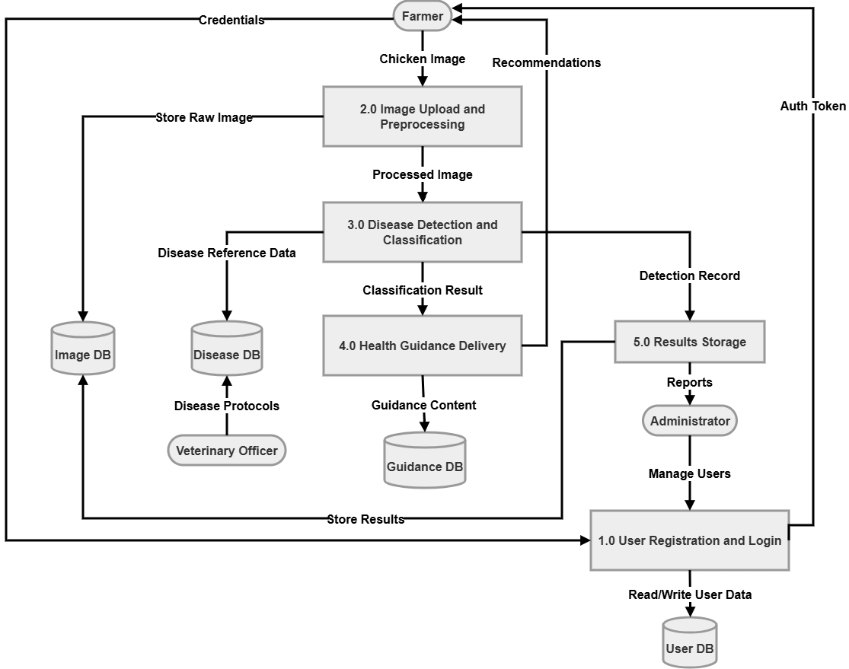
Figure 5:DFD Level 1

4.4.2 Use Case Diagram
The system has two main actors: the Farmer and the Administrator. The Farmer can register an account, log in, upload chicken images, view disease detection results, and access health management guidance. The Administrator has full control over the system, including managing user accounts, monitoring detection history, and reviewing system performance.
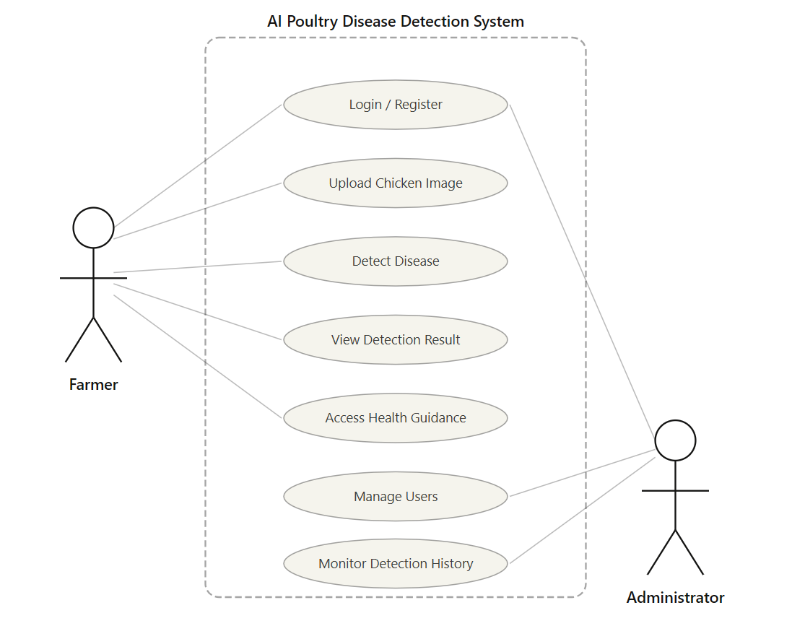
Figure 6:Use Case Diagram

4.4.3 Entity Relationship Diagram (ERD)
The Entity Relationship Diagram (ERD) shows the database structure and the relationships between the main entities in the system. The system database consists of two primary entities: Users and Detections. The Users entity stores account information for all registered users including farmers and administrators, such as their name, email address, password, and role. The Detections entity stores the records of each disease detection activity performed by a user, including the uploaded image reference, the detected disease classification result, the confidence score returned by the AI model, the health management guidance provided, and the timestamp of the detection. A single user can perform many detection activities, establishing a one-to-many relationship between Users and Detections.
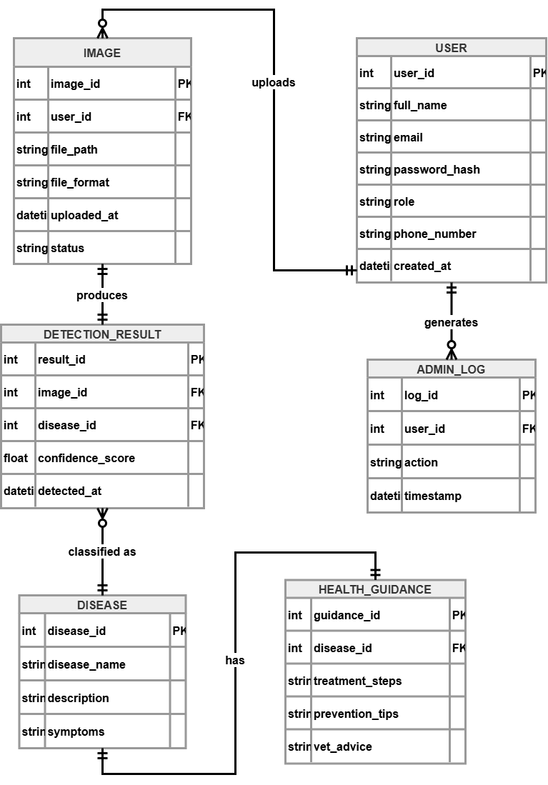
Figure 7:Entity Relationship Diagram (ERD)

4.5 System Implementation
This section presents the actual implementation of the AI-Based Poultry Disease Detection and Health Management System, including the AI model training process, the user interface, and the integration of all system components. Screenshots of the developed system are provided to illustrate the key features and functionalities of the implemented solution.

4.5.1 AI Model Training and Performance
The CNN model was trained using a labelled dataset of poultry disease images collected from Kinini Poultry Farm Cooperative and publicly available sources. The dataset includes images of chickens affected by Chronic Respiratory Disease (CRD), Fowl Pox, and healthy chickens. Images were preprocessed through resizing, normalization, and augmentation before being fed into the model. The dataset was split into training (70%), validation (20%), and testing (10%) subsets.
The model was trained using TensorFlow and Keras with transfer learning applied from a pre-trained CNN architecture. The training process involved multiple epochs with the model's performance monitored using accuracy and loss metrics on the validation set. Early stopping was applied to prevent overfitting.
The table below presents the performance metrics achieved by the trained AI model on the test dataset:
Table 3: AI Model Performance Results
Disease Class | Accuracy (%) | Precision (%) | Recall (%) | F1-Score (%)
CRD | 91.28 | 91.25 | 85.88 | 88.48
Fowl Pox | 91.28 | 94.83 | 100.00 | 97.34
Healthy | 91.28 | 89.40 | 91.08 | 90.23
Table 3: AI Model Performance Results
The confusion matrix below provides a detailed breakdown of the model's classification performance across all three disease categories:
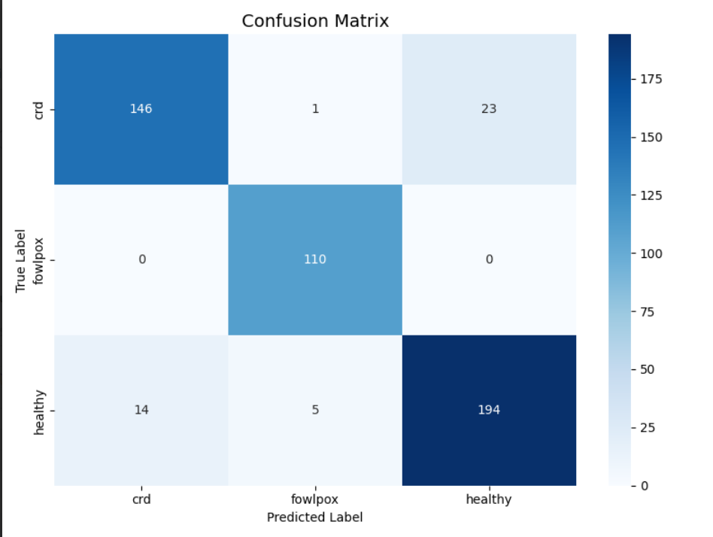
Figure 8:Confusion Matrix of AI Model Performance

4.5.2 User Interface Implementation
The user interface of the AI-Based Poultry Disease Detection and Health Management System was developed as a web-based application designed to be simple, intuitive, and accessible on both desktop and mobile devices. The interface was built to allow farmers to easily upload chicken images and receive disease detection results without requiring technical expertise. The following screenshots illustrate the key pages and features of the implemented system.
4.5.2.1 Login Page
The login page allows registered users including farmers and administrators to securely access the system using their email address and password. The design is clean and straightforward to minimize confusion for users with limited digital literacy.


Figure 9:System Login Page
4.5.2.2 Dashboard Page
The dashboard provides an overview of the system's key information and quick access to the main features. For farmers, the dashboard displays recent detection history and quick access to the image upload feature. For administrators, the dashboard shows system usage statistics, the number of registered users, and recent detection activity.
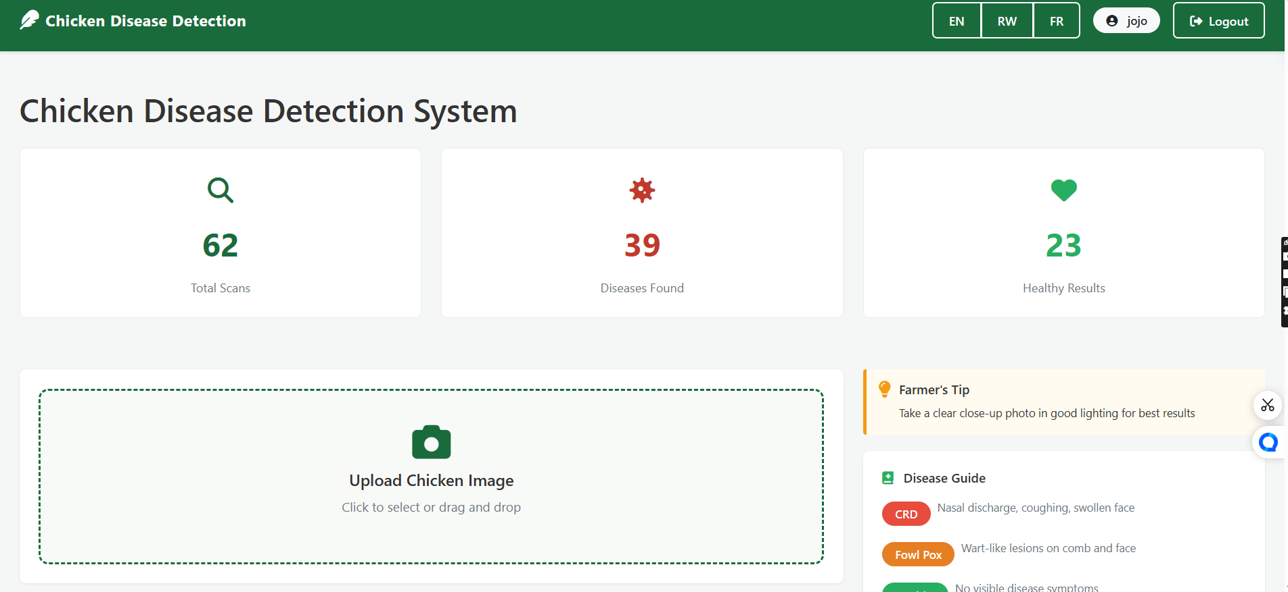
Figure 10:System Dashboard Page
4.5.2.3 Image Upload and Disease Detection Page
The image upload page is the core feature of the system. Farmers can upload a photograph of their chicken in JPG or PNG format. Once the image is uploaded, the system processes it through the trained CNN model and returns the disease detection result along with a confidence score. This page is designed to be as simple as possible, with clear instructions and large interactive elements to support users who may be unfamiliar with web-based applications.
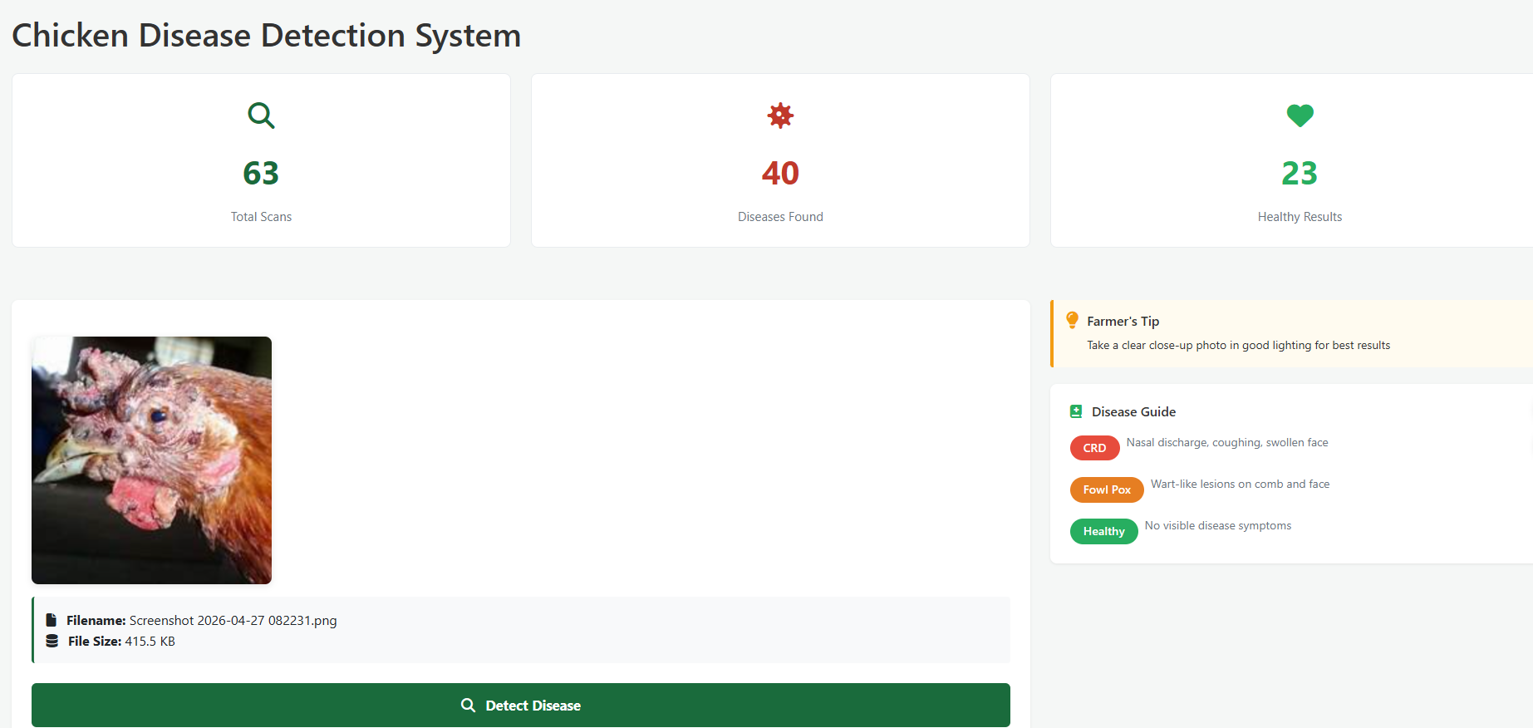
Figure 11: Image Upload and Disease Detection Page
4.5.2.4 Disease Detection Result and Health Management Guidance Page
After the AI model analyses the uploaded image, the system displays the detection result clearly to the farmer. The result includes the name of the detected disease or a confirmation that the chicken appears healthy, along with a confidence percentage. If a disease is detected, the system automatically displays targeted health management guidance providing practical recommendations on the steps the farmer should take to manage or control the detected condition. This guidance includes basic treatment suggestions, preventive measures, and advice on when to consult a veterinary professional.
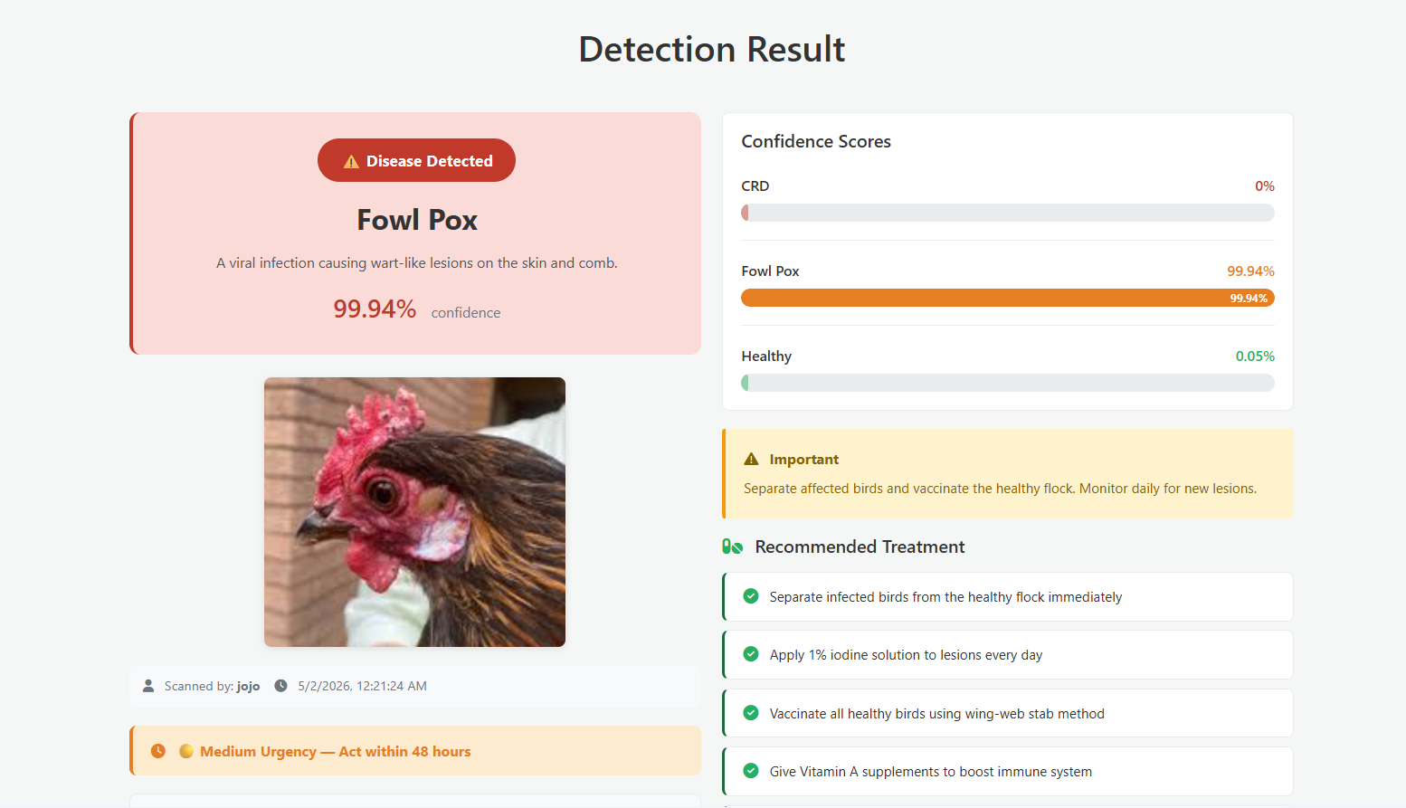
Figure 12: Disease Detection Result and Health Management Guidance Page
4.5.2.5 Admin Dashboard and User Management Page
The administrator dashboard provides full control over the system, allowing administrators to manage user accounts, review detection history, and monitor overall system performance. Administrators can add or remove users, view a log of all detection activities, and access system performance analytics.
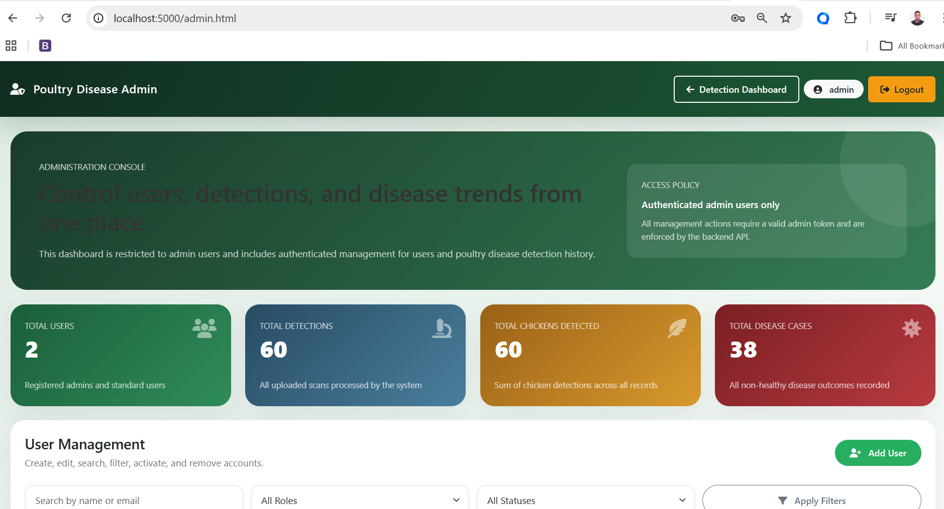
Figure 13: Admin Dashboard and User Management Page

4.5.3 Database Implementation
The database was implemented to securely store all system data including user accounts, uploaded image records, detection results, disease information, and health management guidance content. The database schema follows the structure defined in the Entity Relationship Diagram presented in Section 4.4.3. Appropriate relationships and constraints were implemented to ensure data integrity and consistency across all tables.
The database stores each detection event as a record linked to the uploaded image, the detected disease category, the confidence score returned by the AI model, and the timestamp of the detection. This enables the system to maintain a complete history of detection activities for each user and supports future analysis of disease patterns and system performance trends.

4.6 System Testing and Evaluation
The AI-Based Poultry Disease Detection and Health Management System was subjected to a comprehensive testing and evaluation process to assess its technical performance, functional correctness, usability, and reliability. The evaluation was conducted across four dimensions as described below.

4.6.1 AI Model Performance Evaluation
The trained CNN model was evaluated using the test dataset, which was withheld from the training and validation phases to provide an unbiased assessment of model performance. The model was assessed using accuracy, precision, recall, F1-score, and confusion matrix metrics. The results, presented in Table 3 and Figure 8, demonstrate the model's capacity to correctly classify chicken images into the three categories of CRD, Fowl Pox, and Healthy.

4.6.2 System Functionality Testing
System functionality testing was conducted to verify that all components of the system operate correctly and that all features perform their intended tasks without errors. Testing covered all key functionalities including user registration and login, image uploading, disease detection processing, health management guidance retrieval and display, and administrator dashboard operations. All identified functional defects were corrected before the system was approved for evaluation with end-users.

4.6.3 Usability Testing
Usability testing was carried out with selected poultry farmers and farm personnel at Kinini Poultry Farm Cooperative. Participants were asked to perform a series of tasks using the system, including uploading a chicken image and reviewing the detection result and health management guidance. Feedback was collected through observation and informal interviews. Participants generally found the system interface easy to navigate, with the image upload and result display features being particularly well received. Suggestions for improvement were noted and incorporated into the final version of the system.

4.6.4 Reliability Testing
Reliability testing was performed by running the system multiple times using different chicken images from all three disease categories. The testing assessed the consistency and stability of the system's disease detection predictions under varying image conditions including different lighting levels, image angles, and image resolutions. The system demonstrated consistent detection performance across the range of test images, confirming its reliability as a practical disease detection tool for use in real-world farming conditions.

4.7 Summary
This chapter has presented the comprehensive system analysis, design, and implementation of the AI-Based Poultry Disease Detection and Health Management System. The chapter began with a description of the iterative development model adopted for the project, followed by an analysis of the existing manual disease detection system at Kinini Poultry Farm Cooperative and its key limitations. The design of the new system was presented through system architecture diagrams, a block diagram, data flow diagrams at two levels, a use case diagram, and an entity relationship diagram.
The implementation section demonstrated the key components of the developed system including the trained CNN model and its performance metrics, the user interface with screenshots of all major pages, and the database implementation. The chapter concluded with a presentation of the system testing and evaluation results, confirming that the system meets its functional, performance, usability, and reliability requirements.
Chapter Five will present the conclusions and recommendations of the study, summarizing the main contributions of the project, reflecting on the extent to which the research objectives were achieved, acknowledging the study's limitations, and providing recommendations for future research and system development.

CHAPTER FIVE: CONCLUSIONS AND RECOMMENDATIONS

5.1 Main Contribution of the Project
This capstone project has made several meaningful contributions to the fields of artificial intelligence, agricultural technology, and rural development in Rwanda. The primary contribution is the successful design, development, and evaluation of an AI-Based Poultry Disease Detection and Health Management System specifically contextualised for the needs of smallholder poultry farmers at Kinini Poultry Farm Cooperative. A key technological achievement is the development and training of a Convolutional Neural Network (CNN) model capable of classifying poultry diseases from chicken images, demonstrating that AI-based image classification can serve as a reliable and practical disease detection tool in real-world smallholder farming contexts.
Beyond the AI model itself, the project contributes an integrated system that combines disease detection with targeted health management guidance, going further than existing tools that focus solely on classification by providing farmers with practical recommendations after disease detection. The project also addresses the geographic gap in existing literature by developing a system trained on locally collected images from Kinini Poultry Farm Cooperative, contributing to the academic body of knowledge on AI applications in poultry farming in sub-Saharan Africa. Furthermore, the project supports Rwanda's national agenda of digital agricultural transformation, demonstrating how AI technologies can improve productivity and health management in the poultry sub-sector, consistent with the goals of Vision 2050 and the Smart Rwanda Master Plan.

5.2 Conclusions
The development and implementation of the AI-Based Poultry Disease Detection and Health Management System represents a significant and practical advancement in poultry disease management for smallholder farmers in Rwanda, particularly those at Kinini Poultry Farm Cooperative where the study was conducted. The study successfully achieved all five specific objectives set out at the beginning of the project. The existing disease detection practices at the cooperative were assessed, revealing that farmers rely entirely on manual observation with no digital tools or systematic disease tracking in place, confirming the critical need for an automated and reliable solution. A CNN-based AI system was subsequently designed, developed, and trained to detect and classify Chronic Respiratory Disease (CRD) and Fowl Pox from chicken images, confirming that deep learning-based image classification is a technically viable approach for poultry disease detection in the Rwandan smallholder farming context.
A user-friendly web-based interface was implemented, allowing farmers and administrators to upload chicken images, view detection results, and access health management guidance, with usability testing at Kinini Poultry Farm Cooperative confirming that the interface was accessible and easy to navigate even for users with limited digital experience. The health management guidance module was successfully integrated into the system, ensuring that the system not only identifies diseases but also empowers farmers to take informed and timely action to manage detected conditions. In conclusion, this project demonstrates that AI technology — specifically CNN-based deep learning — can be effectively adapted to address the disease detection and health management needs of smallholder poultry farmers in Rwanda, offering a scalable, cost-effective solution with the potential to significantly reduce disease-related losses and improve livelihoods for rural farming households

5.3 Recommendations
Based on the findings and experience gained throughout the development and evaluation of the AI-Based Poultry Disease Detection and Health Management System, the following recommendations are proposed for future development, adoption, and research:

5.3.1 Expand the Scope of Detectable Diseases
The current system is limited to detecting two diseases: Chronic Respiratory Disease (CRD) and Fowl Pox. Future versions of the system should expand the range of detectable conditions to include other common and economically significant poultry diseases in Rwanda such as Newcastle Disease, Coccidiosis, and Infectious Bursal Disease (Gumboro). Expanding the disease scope will increase the system's utility and relevance for a broader range of farming contexts.

5.3.2 Develop an Offline-Capable Mobile Application
The current system requires internet connectivity to function, which may limit its accessibility in rural areas of Rwanda where network coverage is unreliable. It is recommended that a future version of the system be developed as an offline-capable mobile application that can perform disease detection locally on the device without requiring a continuous internet connection.

REFERENCES
Akter, S., et al. (2021). Poultry disease detection using deep learning with transfer learning. International Journal of Advanced Computer Science and Applications, 12(3), 415-423.
Davis, F. D. (1989). Perceived usefulness, perceived ease of use, and user acceptance of information technology. MIS Quarterly, 13(3), 319-340.
Food and Agriculture Organization of the United Nations (FAO). (2020). Poultry Development Review. Rome: FAO.
Geere, J., et al. (2018). Carrying water may be a major contributor to disability from musculoskeletal disorders in low income countries: a cross-sectional survey in South Africa, Ghana and Vietnam. Journal of Global Health, 8(1).
Goodfellow, I., Bengio, Y., & Courville, A. (2016). Deep Learning. MIT Press.
Islam, S. M. S., et al. (2022). Wearable cuffless blood pressure monitoring devices: a systematic review and meta-analysis. European Heart Journal - Digital Health, 3(2), 323-337.
Keras. (2023). Keras Documentation for Image Classification and Neural Networks. Retrieved from https://keras.io
Machuve, D., et al. (2022). Poultry diseases diagnostics models using deep learning. F1000Research, 11, 1-18.
Mohanty, S. P., Hughes, D. P., & Salathe, M. (2016). Using deep learning for image-based plant disease detection. Frontiers in Plant Science, 7, 1419.
Neethirajan, S., et al. (2021). Artificial intelligence and sensor technologies in poultry export: charting a digital transformation. Sensors, 21(14), 4777.
Rogers, E. M. (2003). Diffusion of Innovations (5th ed.). Free Press.
TensorFlow. (2023). TensorFlow Documentation for Machine Learning and Deep Learning Applications. Retrieved from https://www.tensorflow.org
Theckedath, D., & Sedamkar, R. R. (2020). Detecting affect states using VGG16, ResNet50 and SE-ResNet50 networks. SN Computer Science, 1(2), 79.
World Organisation for Animal Health (WOAH). (2021). Manual of Diagnostic Tests and Vaccines for Terrestrial Animals. Paris: WOAH.

